THE GUIDE TO ROOFING

The PVGames roof tiles are probably the most confusing and hardest-to-use tiles I have produced. The angles required to make 2.5D roofs are not the same predictable angles required for walls, furniture, doors, and other such objects. It is my hope that this guide will help people better understand and utilize the roof tiles.
Firstly, let’s get familiar with the different roof pieces.

Main Face Tiles:
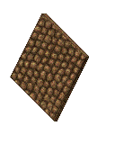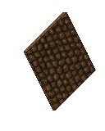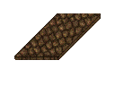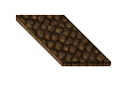
These four are the main face tiles and will comprise the bulk of most roofs. From left to right are the Southwest, Southeast, Northwest, and Northeast facings. These fill in the middle sections along the length of the roof.

Corner Tiles:
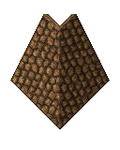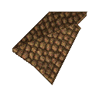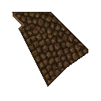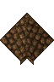
These four are the corner tiles, facing South, West, East, and North respectively. These cap the corner junctions formed by the Main Face tiles.

Inverted Corner Tiles:
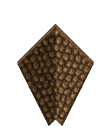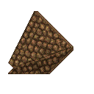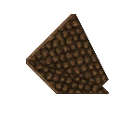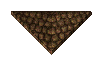
These four pieces are similar to the corner pieces, except they are for inverted segments of the roof. From left to right here we have the South, West, East, and North facing inverted corners.

Roof Toppers:
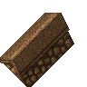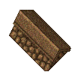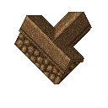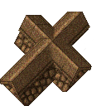
And lastly we have these usually optional pieces that sit affixed to the very top parts of your roof where the other pieces ultimately meet.

Typical Use

Here you will be shown the typical use and placement of each type of roof tile. For this guide, I will be using GIMP and GIMP settings, but the technique shown here can be used in any image manipulator program that allows for grids and/or grid-snapping. You can also use TileD (this would also work in RPG Maker when the grid is set to 32x32).
The first thing that needs to be done is to create a new blank canvas. For this guide, I am going to use a 480x480 canvas to build a very small house. When you have your blank canvas open, toggle “Show Grid” to on, under the “View” tab and then under the “Images” tab, select “Configure Grid” and set the “Spacing” to 32 for both horizontal and vertical:
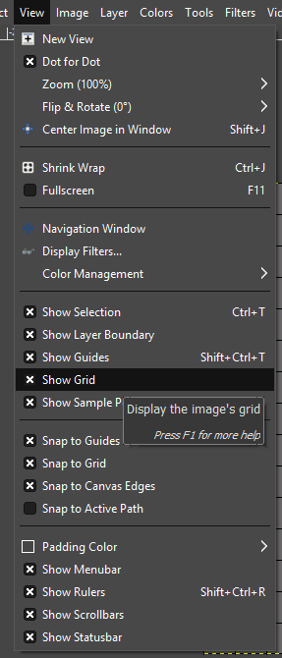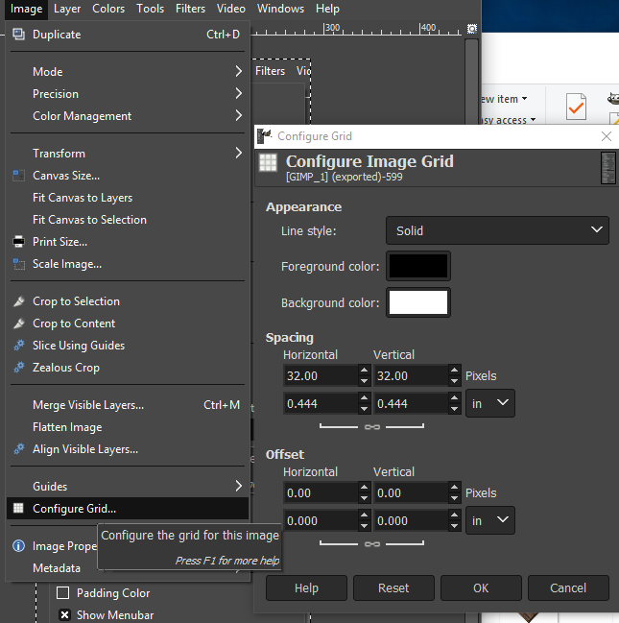
Be sure to also click to enable “Snap to Grid” under the “View” tab. Now you have a snappable 32x32 grid!

For this guide, I am going to skip the part where we make the base of the house (see the Building Pieces guide) and use a very simple square house, as thus:
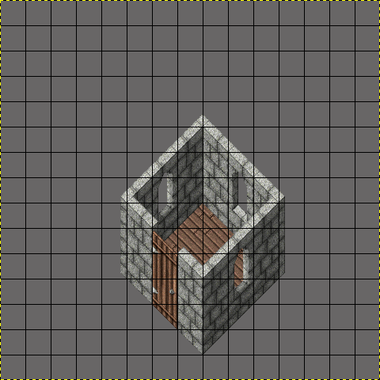
The easiest way to lay your roof tiles is to start at the top-most point (the North point) and work your way down along the Northwest and Northeast sides, and then finally working down towards the bottom-most point (the South point) along the Southwest and Southeast sides.
First we start with our Main Face tiles:
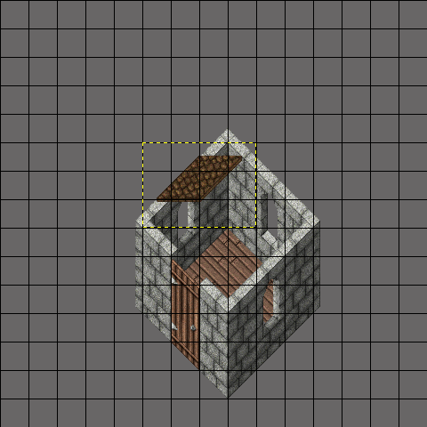
Note here the placement of this first tile. The bottom left point of the roof should touch the far West side of the wall (far East side of the wall if using the Northeast Main Face tile). Also note that there is a small gap at the very top. This is normal and will be filled in with the North Corner piece afterwards. Next we finish filling the Northwest and Northeast portions.
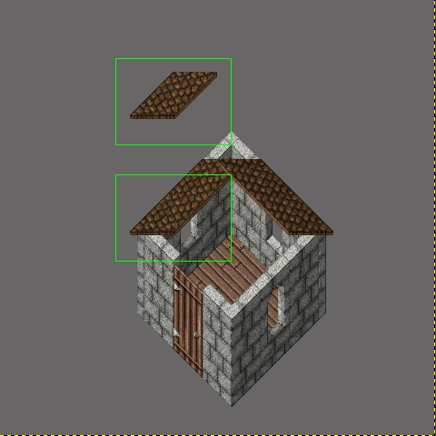
Also note that the pieces will overlap each other. This is supposed to happen and is required to function properly (primarily to allow for overhangs and to compensate for various wall types and designs).
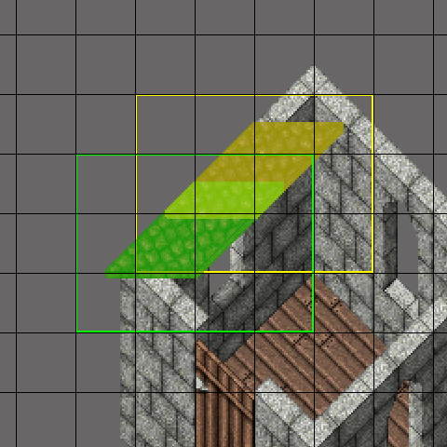
Here is another view of what is happening with the overlap, and roughly how much of the tile needs to overlap. The yellow roof tile in the left image is the first one placed. The green roof tile is the second one placed, on top of the first. The middle greenish-yellow portion is the overlap. The green and yellow box outlines show that each tile needs to be placed one grid square apart.
This concept is the same for all of the roof tiles and the main thing to remember is that these tiles need to be placed one grid square apart and need to overlap one another. More specifically, the tiles “lower on the screen” need to overlap on top of the tiles “higher on the screen”.

Once the Northeast and Northwest Main Facing tiles are in place, we can place the Southeast and Southwest Main Facing tiles. Again, note roughly where the first tiles are supposed to be placed. Gaps near the corners are supposed to be there and will be taken care of by the Corner tiles.
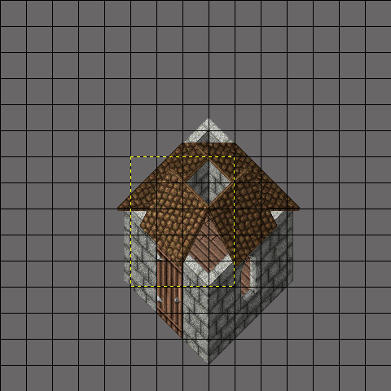
And keep noting that there should be some amount of overhang at the bottom of the roof tiles and they should not align with the tops of the walls. Next, we are going to place the North, East, West, and South Corner pieces in that order.
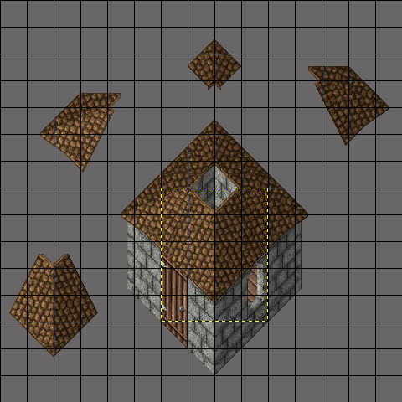
Having the Main Face tiles already in place, where the Corner pieces need to go is much easier to visually recognize. These pieces will cover up all of the gaps left behind by the Main Face tiles and complete the first portion of the roof. If your roof needs to be larger than this demonstration house (as in, your building is a lot larger) you would then just repeat the above steps for the second layer, and third layer if necessary. More examples will be shown later in this guide.
To finish off a roof like this, you can place whatever Roof Topper you feel is appropriate, or you can even use a floor tile to fill the gap.

Alternative Roof Style
The roof style shown above might not always be the most appropriate or desired-looking roof for your building. The Roof tiles here are flexible enough to allow for you to make other types of roofs as well. For example, using primarily just the Northwest and Southeast Main Facing tiles:
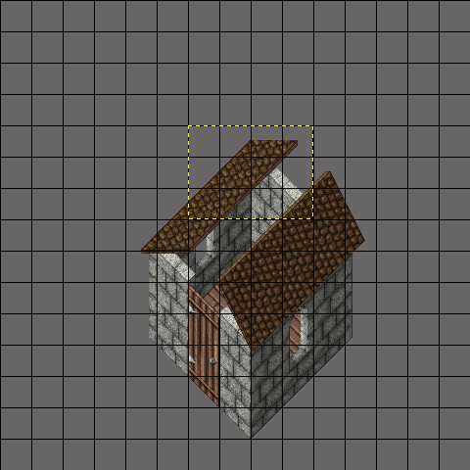
Like before, we start at the top-most point and work towards the bottom-most point. The key difference with this style of roof versus the previous style is that it requires the first pieces to be placed as shown above in order to remove the gap that would otherwise be present (since we are not going to be using any of the Corner pieces).
With the first layer done, we can now apply the appropriate Roof Topper:
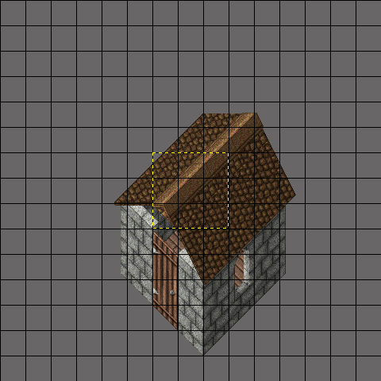
Once more, with the Main Face tiles in place, it is very easy to visually identify where the Roof Topper will need to be placed. And with that, our roof is complete!
But, as you can tell, there is a gap between the wall and the roof! Never fear, you can add the Small and Medium Wall pieces to the top of the wall pieces to form a short wall that will hide under the roof.

Inverted Roof Tiles
So you have seen the Main Face tiles and the Corner tiles at work, but what about the Inverted Roof tiles? These are primarily used when a building has an irregular shape (that is to say, isn’t perfectly square or rectangular). For this demonstration, I have created a different base for my building, as so:
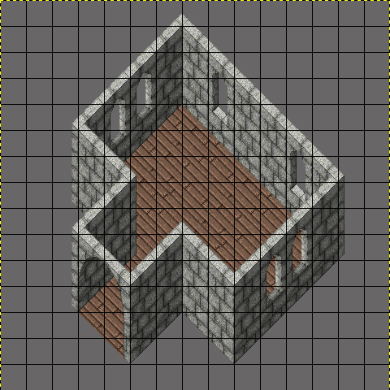
So, beginning with the Main Face Tiles on the Northwest and Northeast sides, followed by the Southwest and Southeast sides, the initial layer for the roof will look like this:
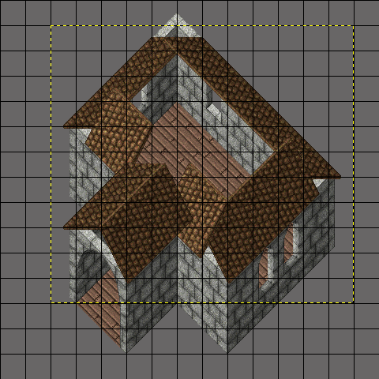
Next we will add the regular Corner Tiles to the North, East, West and South corners:
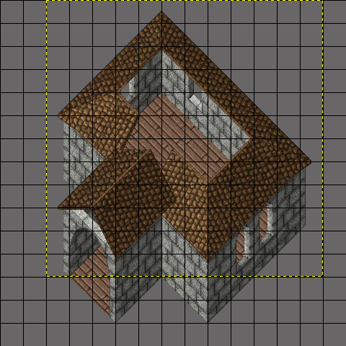
And now we add the Inverted Roof Tiles:
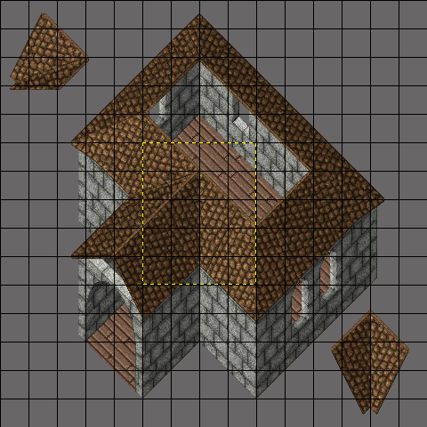
Like the Corner tiles, the Inverted Corner pieces are fairly easy to visually place when the Main Face tiles are in place. With the base of the roof in place, next we just add the next layer to finish the roof like so:
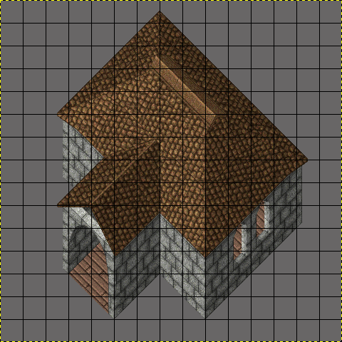
By following the above steps, the top part of the roof is filled in first with the Main Face tiles, followed by the appropriate Corner tiles, and lastly followed by an appropriate Roof Topper.

